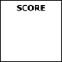Name: ___NOEFE, Judah Zoe Athaliah________ Date: _____May 5_____ Course and Year: ____BSCS 2_____ Section: __IAA2___

**TABLE OF CONTENTS**

Website Description………………………………….…..……3

30% Completion………………………………………………..3

50% Completion………………………………………………..5

75% Completion………………………………………………..8

90% Completion………………………………………………12

**Website Description**

Rendered is a digital platform dedicated to showcasing and celebrating the work of digital artists worldwide. It serves as a virtual gallery where artists can display their creations, connect with other creatives, and gain recognition for their work. Through curated artist features, search and filter options, Rendered aims to make digital art more accessible and appreciated, as opposed to other social media platforms where digital art can be overshadowed by algorithms and non-digital art content.

Rendered is designed for digital artists seeking a platform to showcase their work and connect with others in the industry. It also caters to art enthusiasts exploring new digital artwork and emerging trends. Additionally, aspiring artists can use Rendered as a source of inspiration and learning, discovering various styles and techniques. By bringing together creators, admirers, and learners, Rendered fosters a vibrant community centered around digital art.

**30% Completion**

* Homepage: Basic layout and structure including a welcoming message.
* Navigation Bar: Only the homepage works, other pages are clickable but do not have content yet.

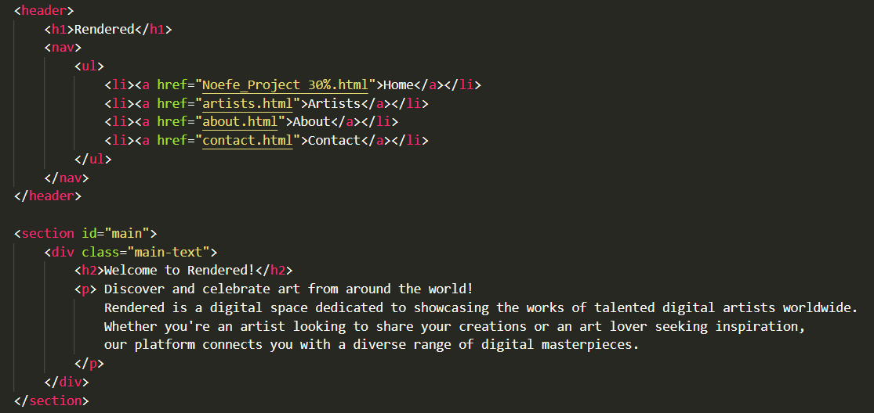

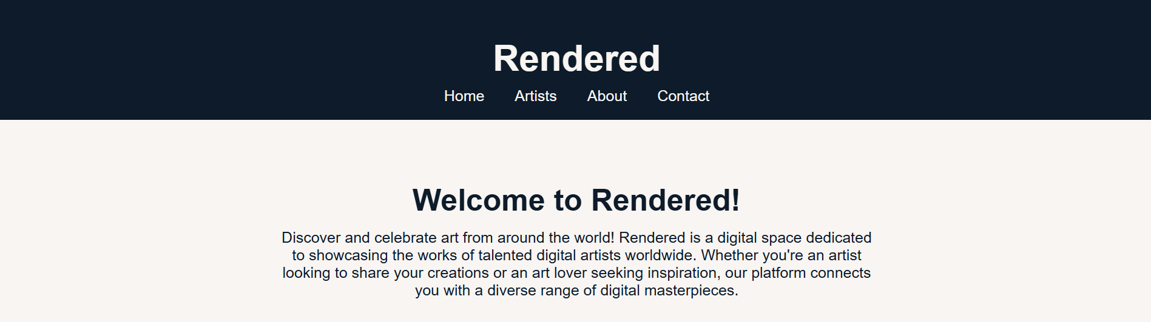

* Search Bar: Not yet functional.

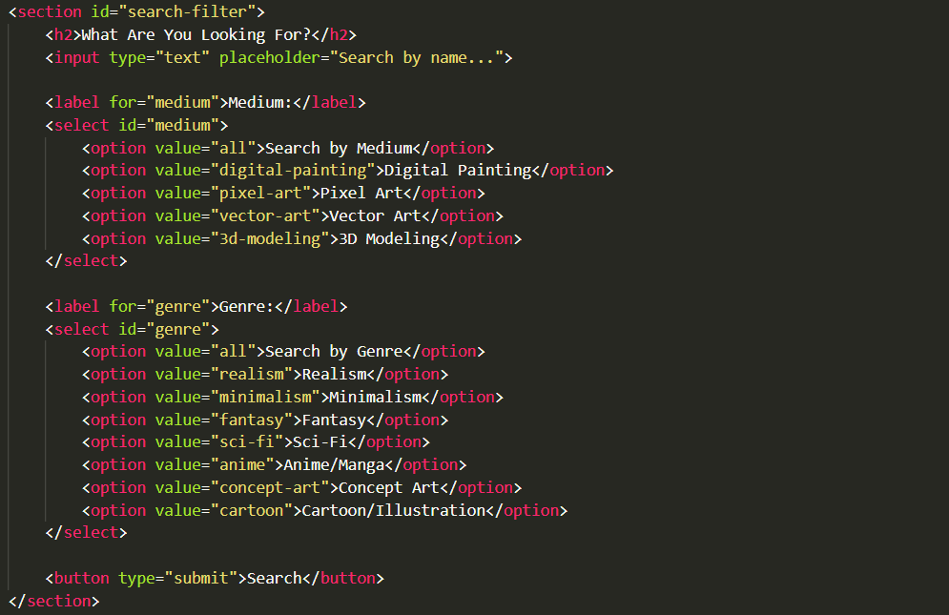



* Featured Artists Section: Only placeholders for images, no images are used. Sizes are very small.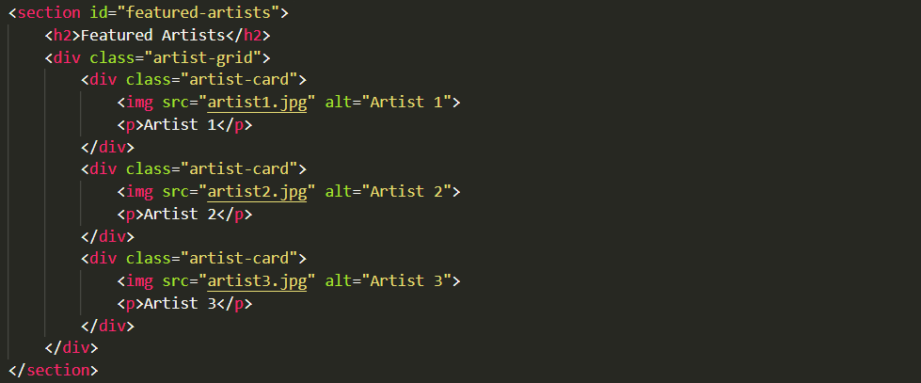

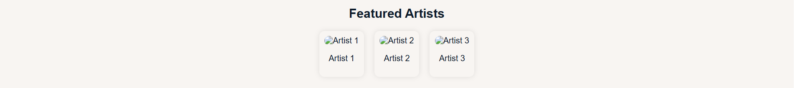

**50% Completion**

Pages Added:

* Artists Page: Introduced with sample layout and placeholder images.

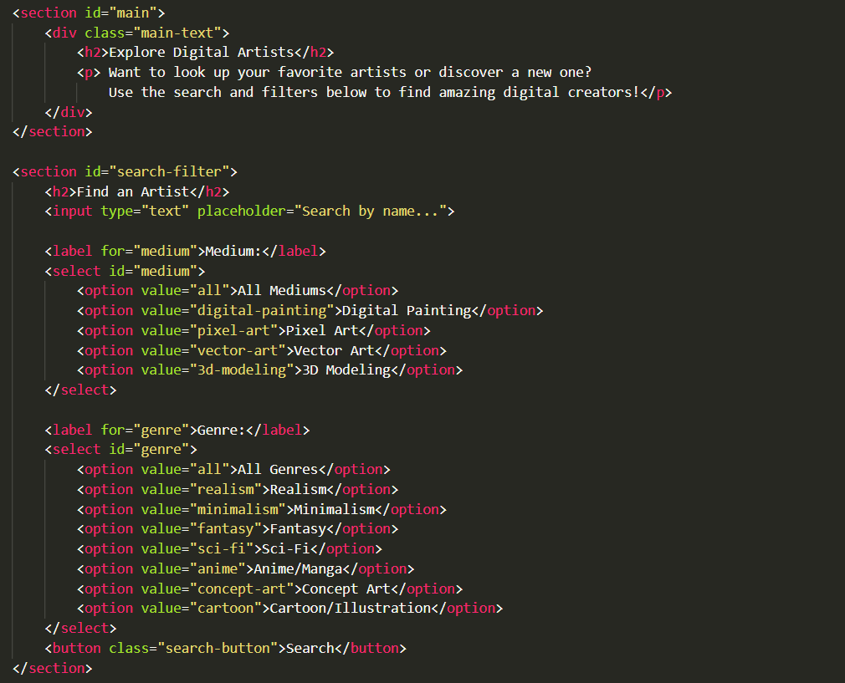

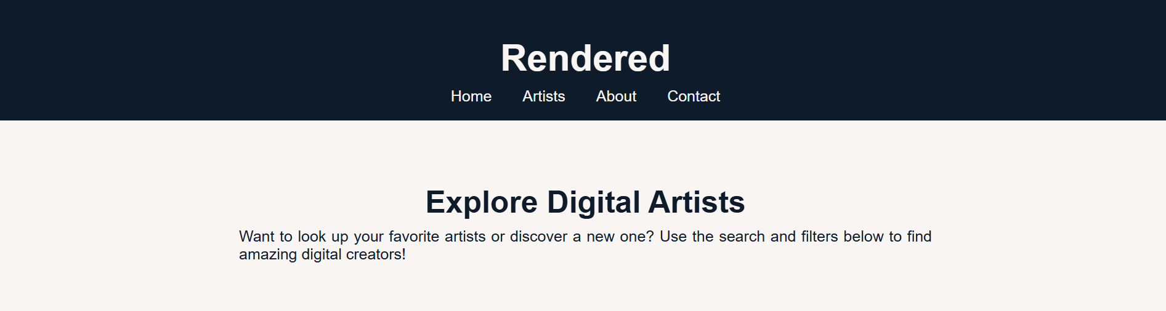

* About Page: Provided an explanation of the site's purpose.

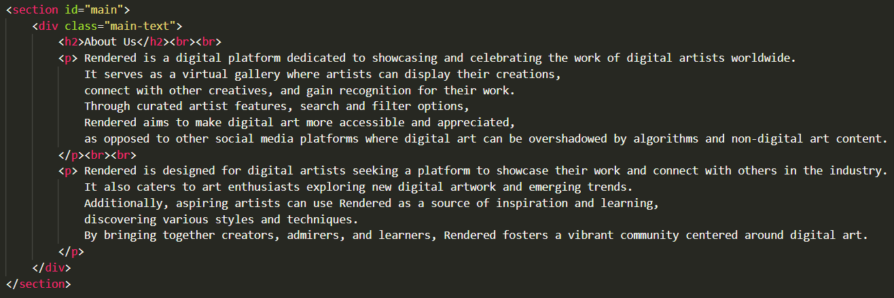

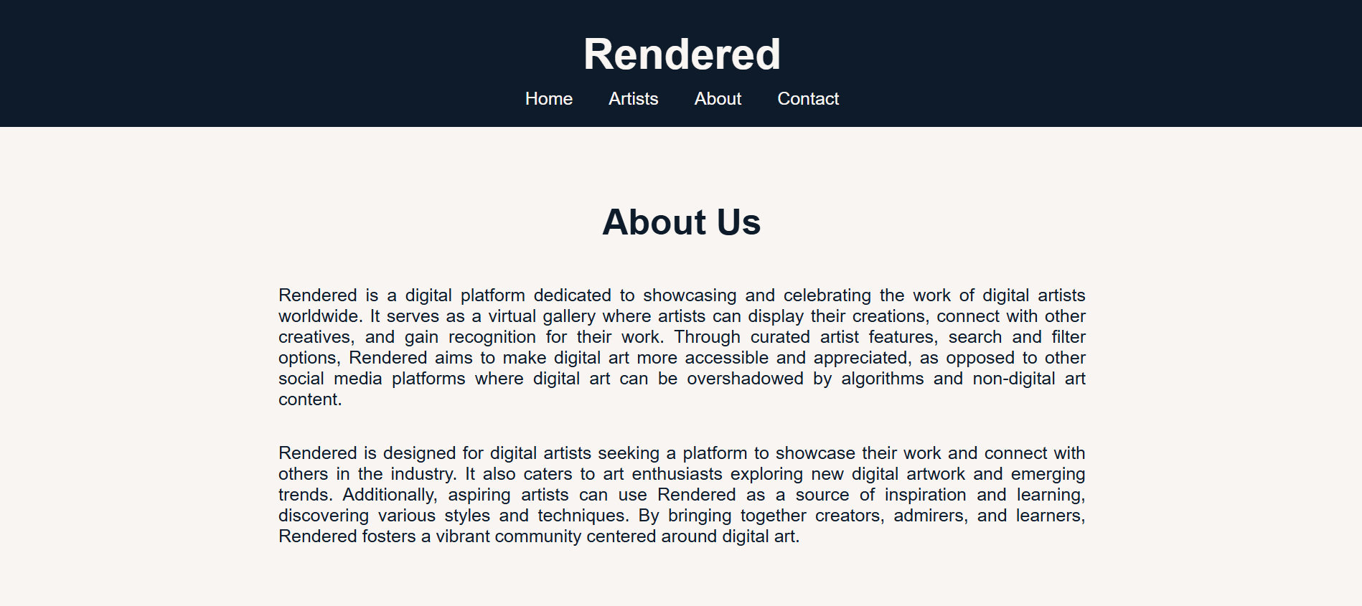

* Contact Page: Offered links for reaching out and submitting artwork.

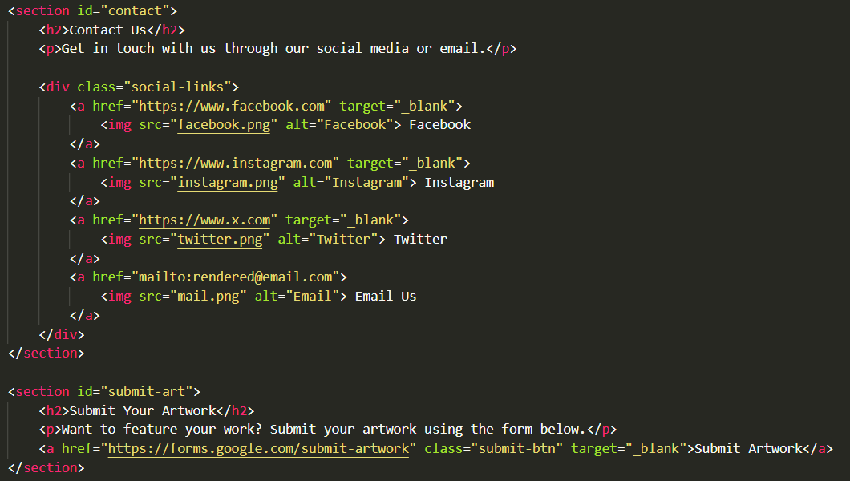

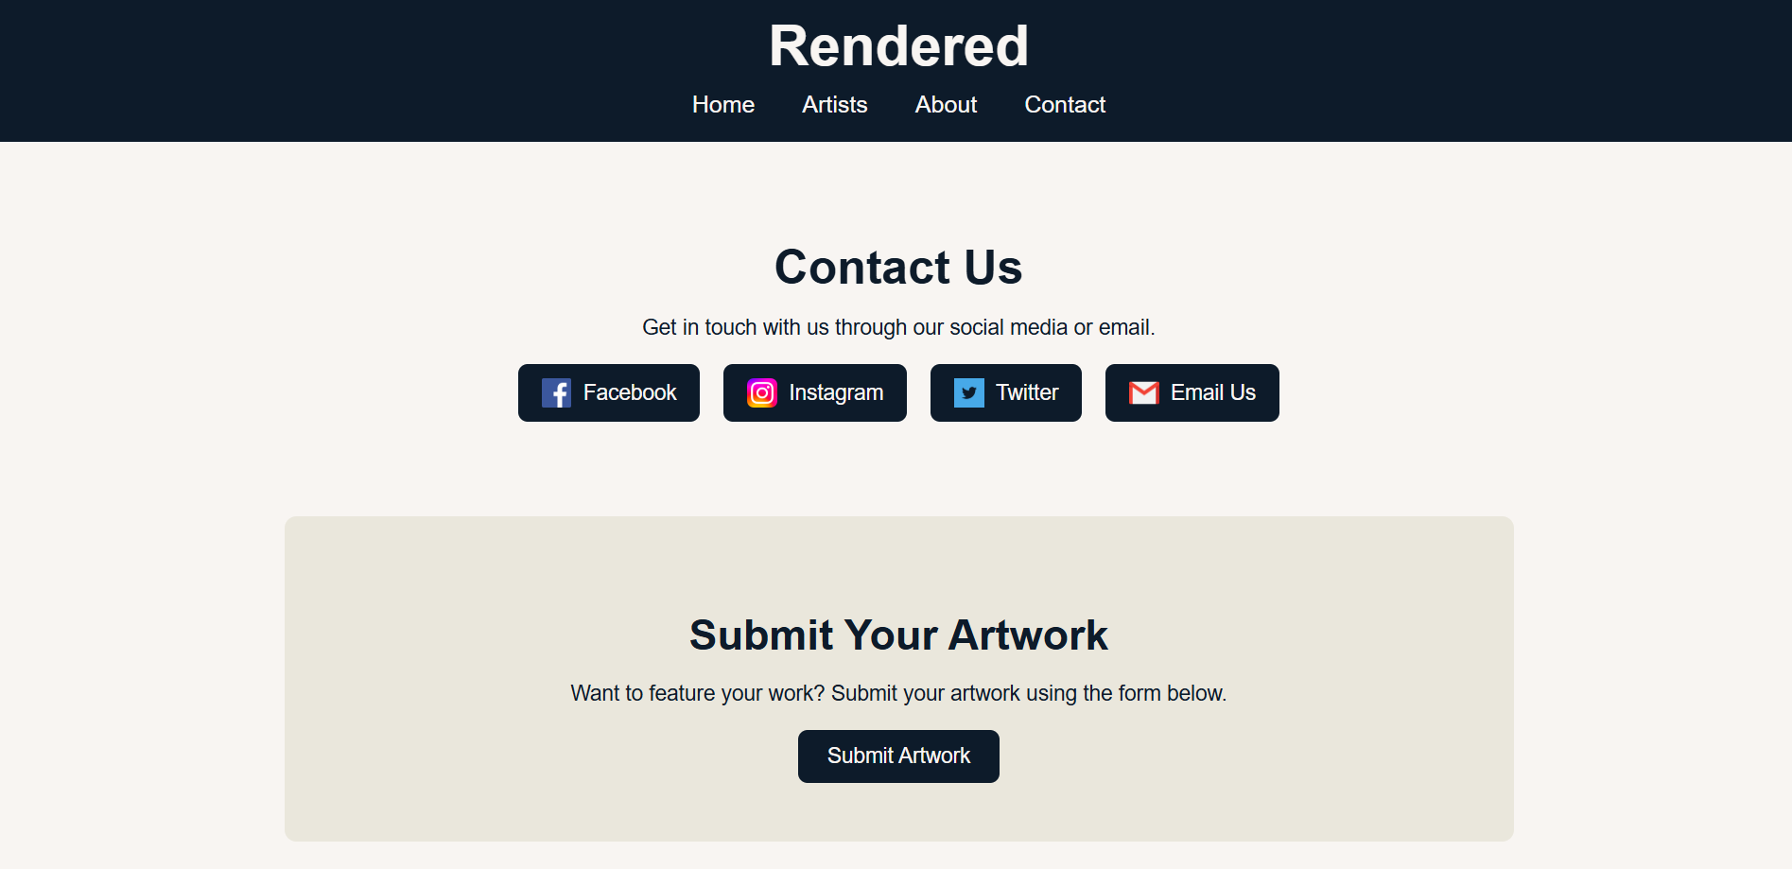

New Elements:

* Artist Profiles: Basic info, bio, and social links included.

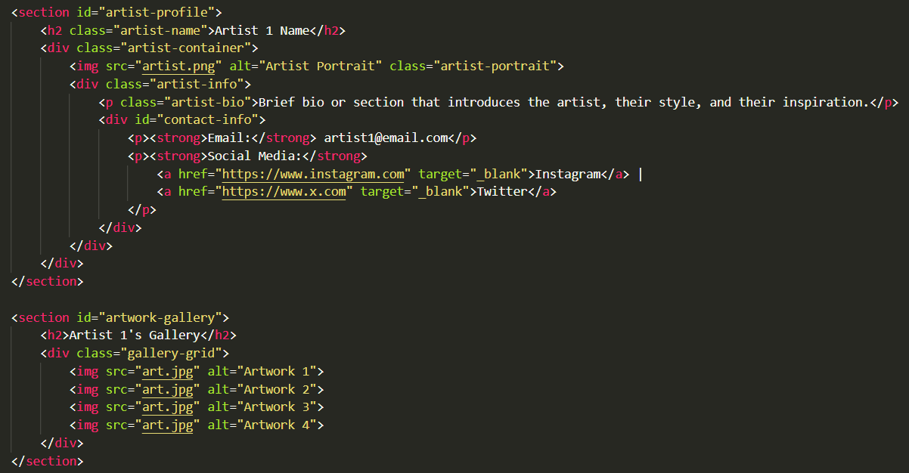

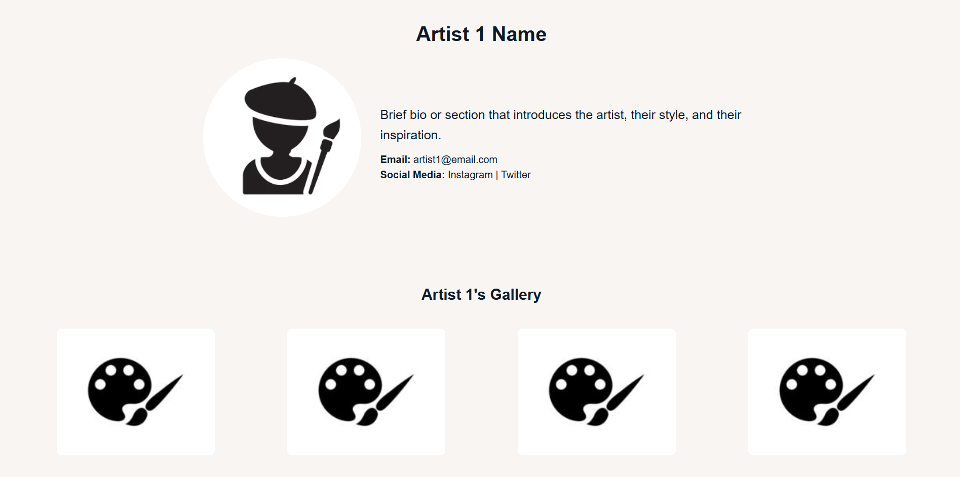

* Gallery Grid: Introduced a grid layout for displaying artist work.

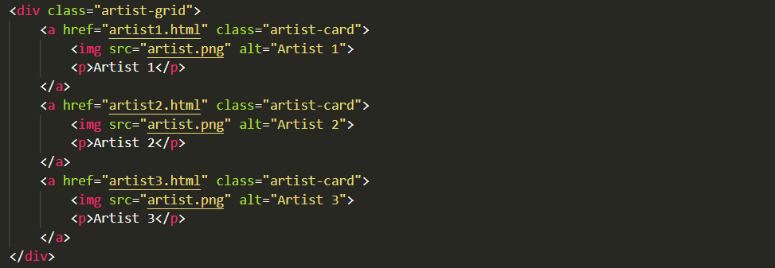

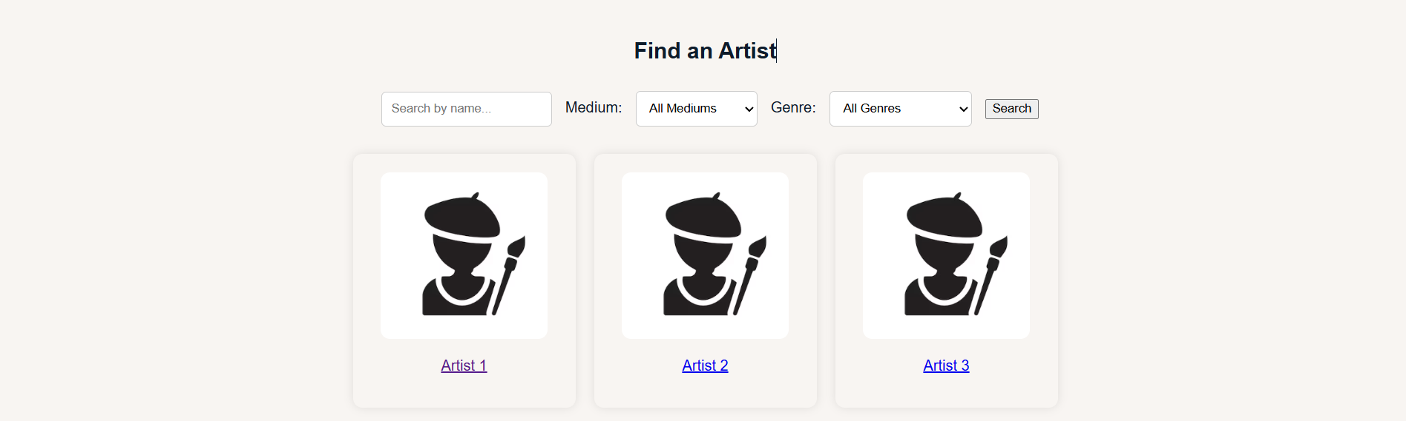

Design Enhancements:

* Adjusted font sizing for consistency across sections.
* Implemented color consistency with off-white backgrounds and navy elements.

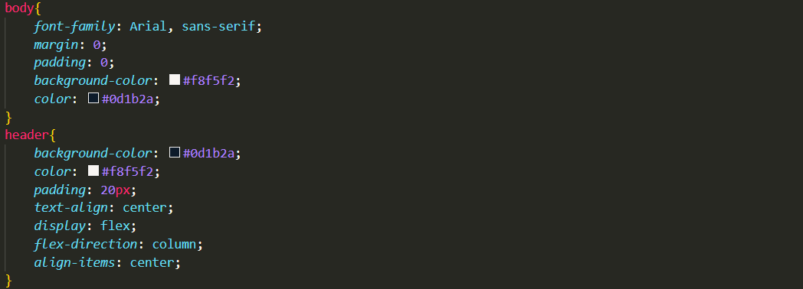

* Added hover effects to buttons and links to improve interactivity.





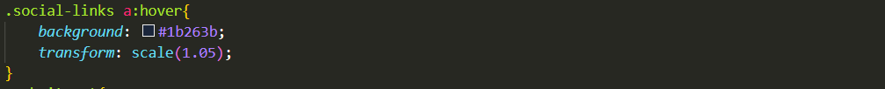

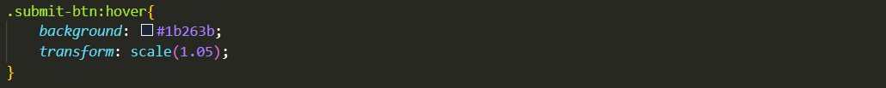

**75% Completion**

* Search Bar Redesigned: Now functional with filters and dropdowns, including checkboxes. However, the search function itself does not yet work.

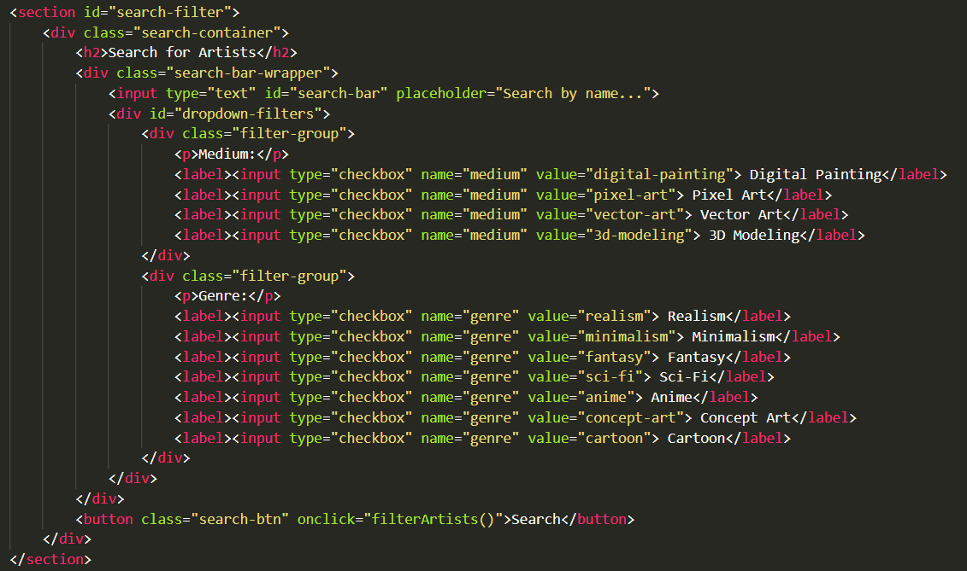

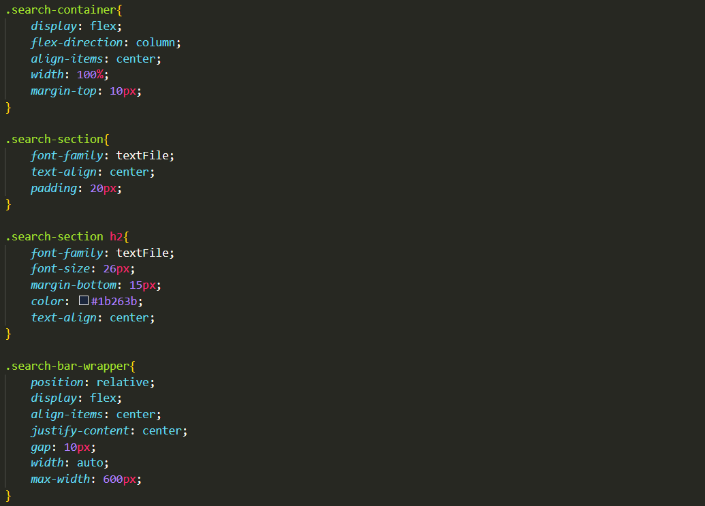

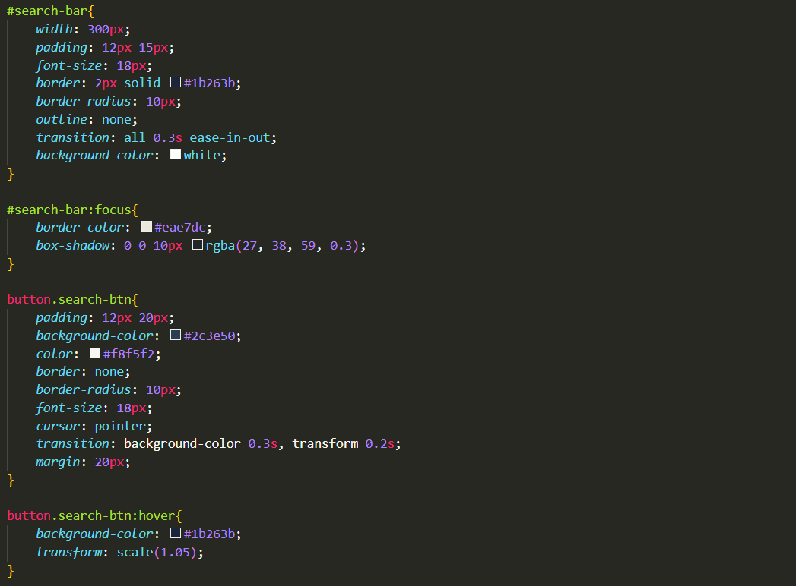

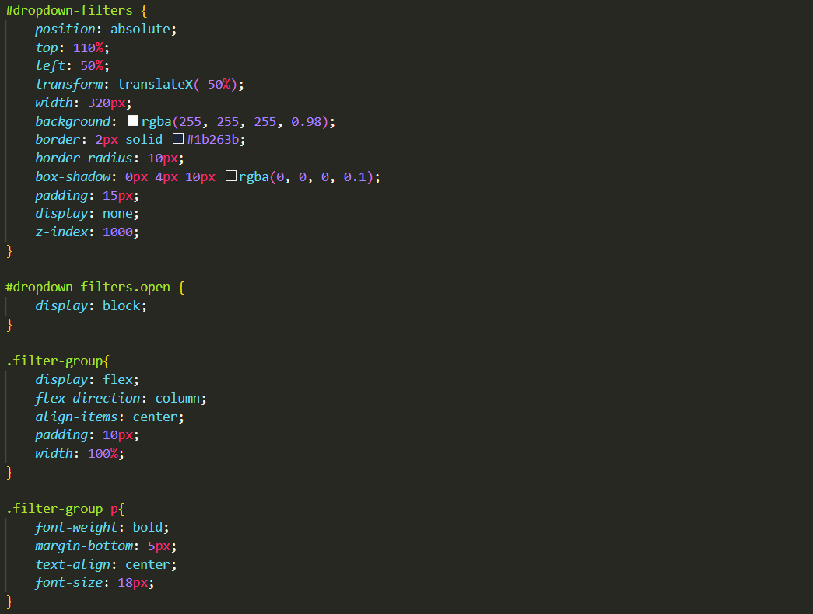

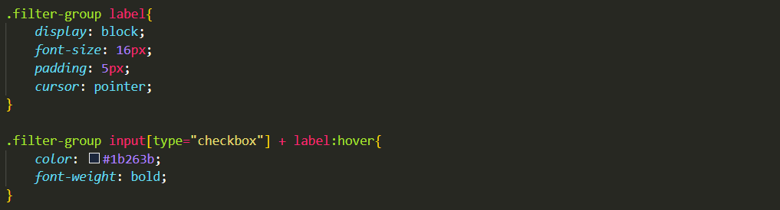

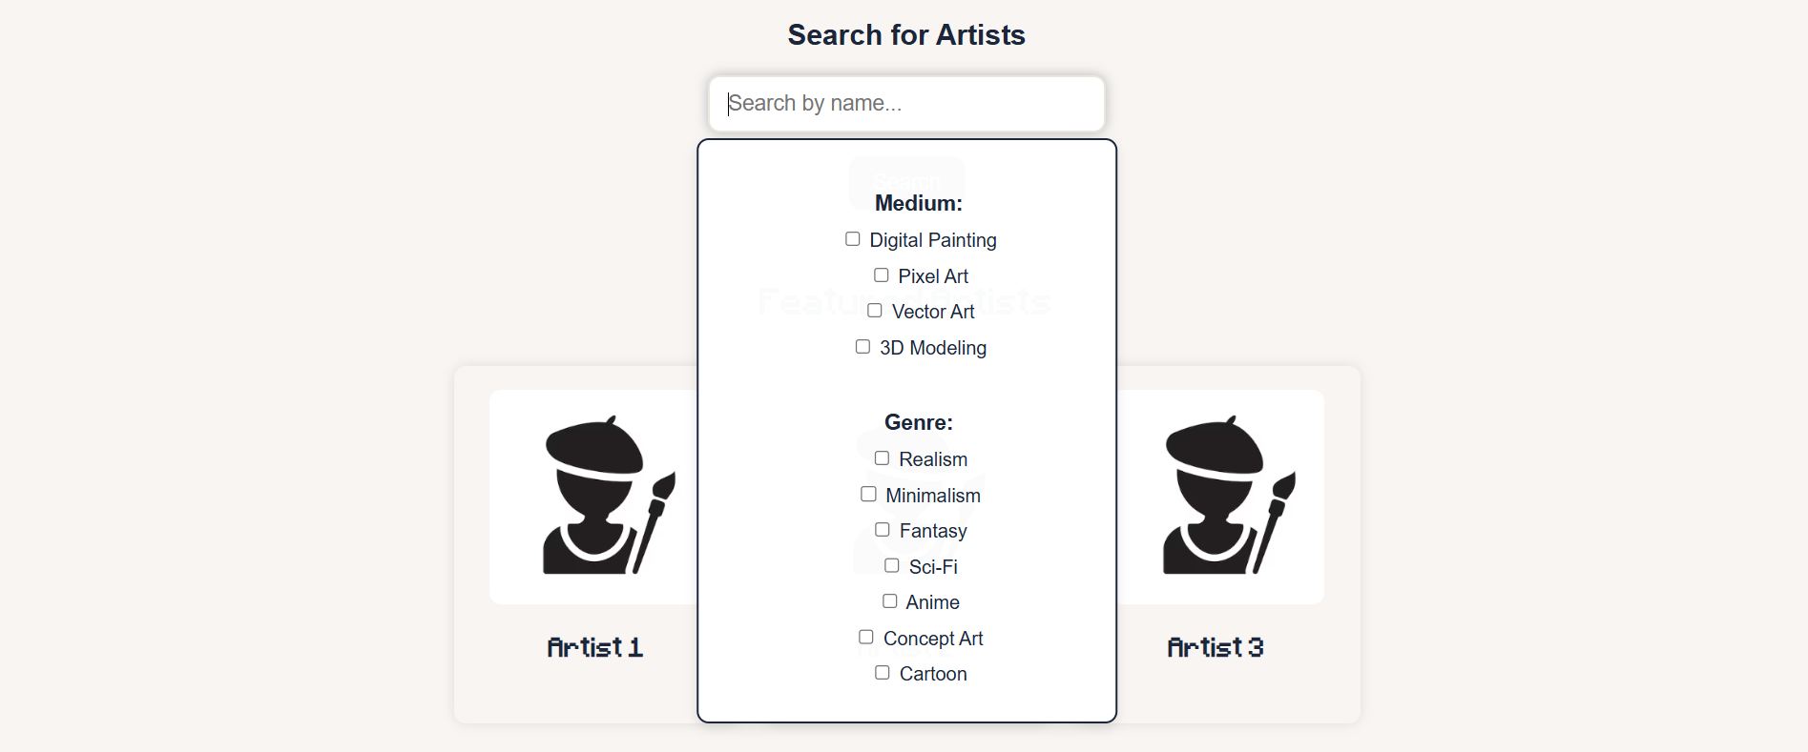

* Tags on Artists Page: Visual tags now included under artist bios to indicate the medium and/or genre they are categorized under.

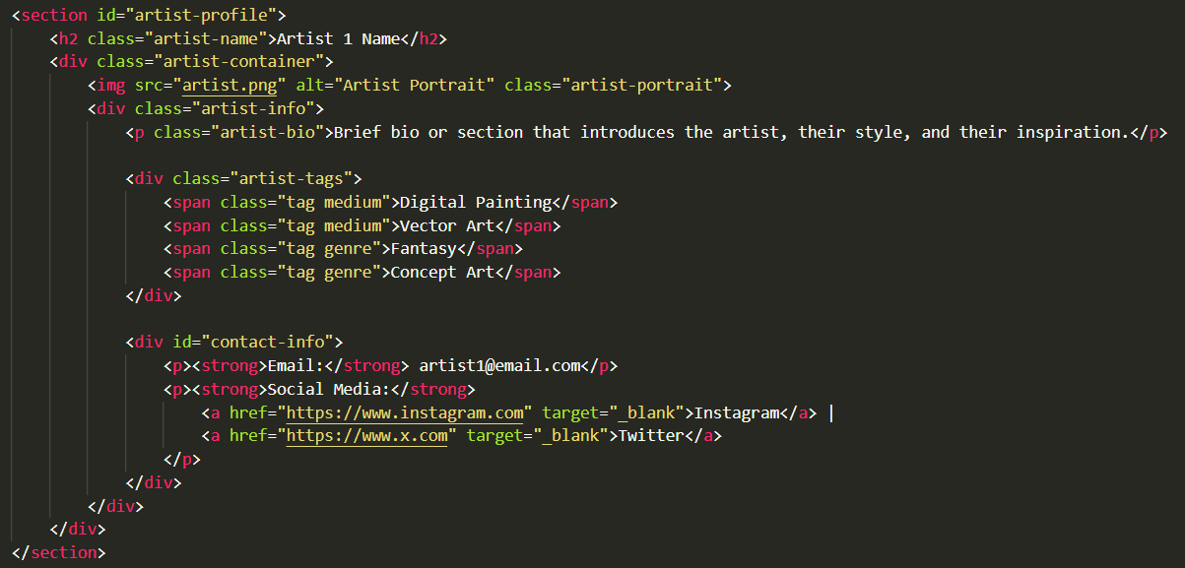

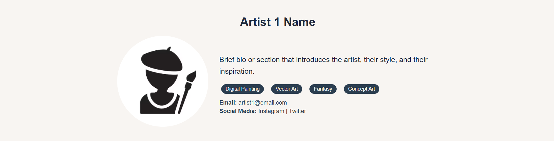

* Header & Navigation Tuning: Better spacing, scaling on hover, and font balance.

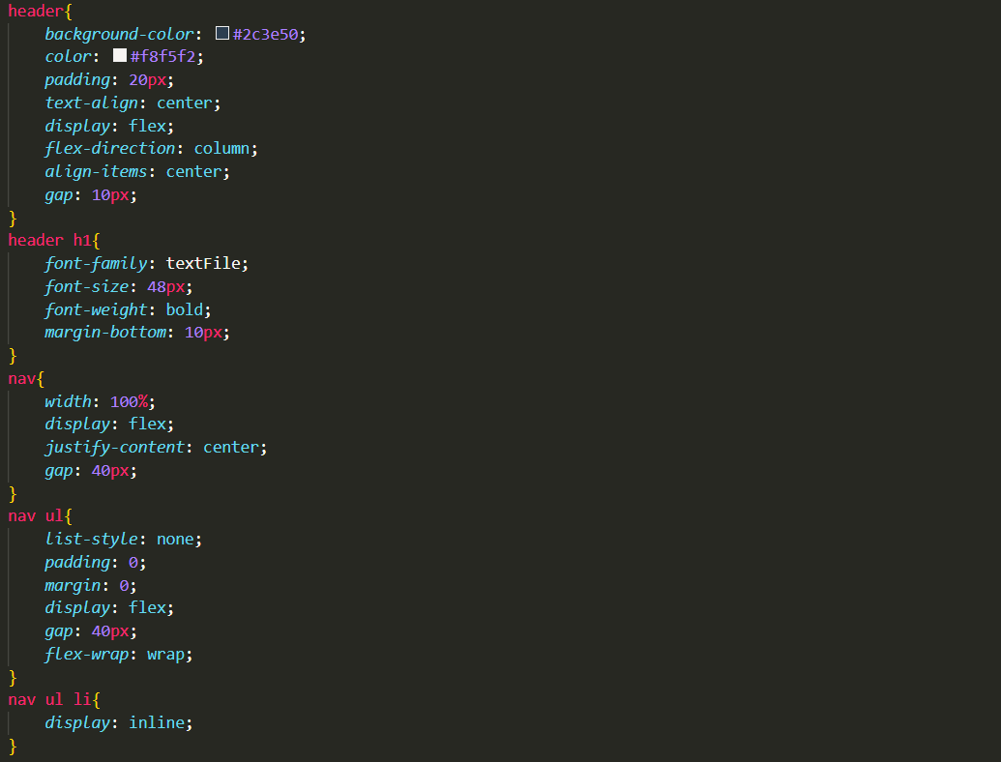

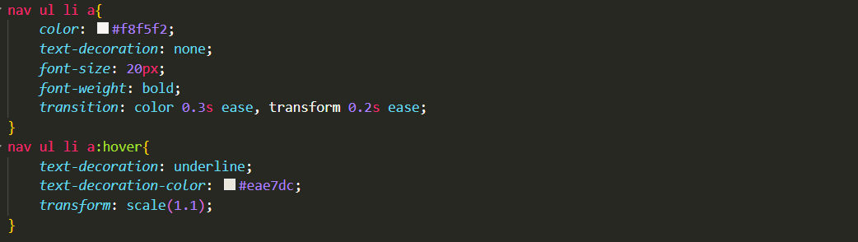

* New Logo Integration: Implemented the Minecraftia font for a retro-modern look. This makes the brand identity stand out a little bit more while staying minimal.



Styling Updates:

* Changed background from #0d1b2a to #2c3e50 for a clearer navy tone.
* Tag & Button Highlights: Hover darkened #1b263b for consistency.